EXPERIMENT ASSESSMENT
ACADEMIC YEAR 2025-26

Course: Multidisciplinary Minor

Course code: MDC401

Year: SE SEM: IV

Experiment No. 6
AIM: Create a webpage that retrieves, displays, and updates user data from a MySQL database. Implement CRUD operations (Create, Read, Update, Delete) using PHP & MySQL. Ensure user input is validated and securely stored in the database.
Name: Ashish Ramesh Patel
Roll Number: 55
Date of Performance:
Date of Submission:

Evaluation
Performance Indicator | Max. Marks | Marks Obtained
Performance | 5
Understanding | 5
Journal work and timely submission. | 10
Total | 20

Performance Indicator | Exceed Expectations (EE) | Meet Expectations (ME) | Below Expectations (BE)
Performance | 5 | 3 | 2
Understanding | 5 | 3 | 2
Journal work and timely submission. | 10 | 8 | 4

Checked by

Name of Faculty : Dr. Yogesh Pingle

Aim: Create a webpage that retrieves, displays, and updates user data from a MySQL database. Implement CRUD operations (Create, Read, Update, Delete) using PHP & MySQL. Ensure user input is validated and securely stored in the database.

Theory:
Modern web applications often require interaction with databases to store, retrieve, and manage user information efficiently. This experiment focuses on developing a dynamic web application using PHP and MySQL that performs CRUD operations (Create, Read, Update, Delete) on user data. Additionally, the application ensures input validation, secure data storage, and incorporates Sessions and Cookies for user management
- PHP and MySQL Integration
PHP (Hypertext Preprocessor) is a server-side scripting language widely used for web development. It is especially suitable for database-driven applications because it can easily interact with databases like MySQL.
MySQL is an open-source relational database management system (RDBMS) used to store structured data in tables. PHP communicates with MySQL using extensions such as MySQLi or PDO (PHP Data Objects) to execute SQL queries.
In this experiment, PHP scripts handle database connections, execute SQL commands, and dynamically generate HTML output based on database records.

CRUD Operations
CRUD represents the four fundamental database operations:

1. Create (Insert)
The Create operation is used to add new user records into the database. User data is collected through HTML forms and sent to the server using HTTP POST method. PHP processes the input and inserts validated data into the MySQL table using the INSERT SQL statement.

2. Read (Select)
The Read operation retrieves user data from the database and displays it on the webpage. PHP executes the SELECT SQL query and fetches records, which are displayed dynamically in tabular format. This operation allows users to view stored data.

3. Update
The Update operation modifies existing user records. The selected record is loaded into an HTML form, allowing the user to edit data. PHP then updates the record in the database using the UPDATE SQL statement.

4. Delete
The Delete operation removes unwanted records from the database using the DELETE SQL statement. This operation helps maintain accurate and relevant data.

Database Structure
A MySQL database typically contains:
- A database to store application data
- A table to store user information such as ID, name, email, and password
- A primary key to uniquely identify each record
Relational databases ensure data consistency and integrity through structured schema and constraints.

Input Validation
Input validation is essential to ensure that user-provided data is correct and safe. Validation includes:
- Checking for empty fields
- Validating email format
- Restricting input length
- Allowing only valid characters
Validation can be implemented using both client-side validation (HTML/JavaScript) and server-side validation (PHP). Server-side validation is critical, as client-side validation can be bypassed.

Security Measures

SQL Injection Prevention
SQL Injection is a common attack where malicious SQL code is inserted into input fields. To prevent this:
- Prepared statements
- Parameterized queries
are used to securely execute SQL commands.

Password Security
Passwords should never be stored in plain text. PHP provides hashing functions such as password_hash() to securely store passwords and password_verify() to authenticate users.

Sessions
A session is a server-side mechanism used to store user data temporarily across multiple pages. Sessions are commonly used for:
- User login systems
- Authentication
- Maintaining user state
In PHP, sessions are created using session_start() and data is stored in session variables. Session data is automatically destroyed when the browser is closed or the session expires.

Cookies
A cookie is a small piece of data stored on the client’s browser. Cookies are used to:
- Remember user preferences
- Store login information
- Track user activity
Unlike sessions, cookies have an expiration time and remain stored even after the browser is closed. PHP uses the setcookie() function to create cookies.

Dynamic Web Page Behavior
The application dynamically updates content based on database operations. PHP fetches updated records after every CRUD operation, ensuring that the displayed data always reflects the current state of the database.
Algorithm/Procedure:

A. Database Creation
- Start XAMPP/WAMP server.
- Open phpMyAdmin.
- Create a database named userdb.
B. CRUD Operations Flow
- Create a table users with fields:
  - id (INT, Primary Key, Auto Increment)
  - name (VARCHAR)
  - email (VARCHAR)
  - password (VARCHAR)
Steps:
- User enters details in HTML form.
- PHP validates user input.
- Data is securely inserted into MySQL database.
- Existing records are fetched and displayed.
- User can update or delete records.
- Sessions manage login state.
- Cookies store user preference.
Code:

▪ Db.php:

<?php
$host = '127.0.0.1';
$user = 'root';
$pass = '';
$dbname = 'mdm\_exp6';
$port = 3306;
$conn = new mysqli($host, $user, $pass, $dbname, $port);
if ($conn->connect\_error) {
die("Connection failed: " . $conn->connect\_error);
}

▪ register.php

<?php
require 'db.php';
$message = '';
if ($\_SERVER\["REQUEST\_METHOD"] == "POST") {
$username = trim($\_POST\['username']);
$email = trim($\_POST\['email']);
$password = $\_POST\['password'];

if (empty($username) || empty($email) || empty($password)) {
$message = "All fields are required!";
} elseif (!filter\_var($email, FILTER\_VALIDATE\_EMAIL)) {
$message = "Invalid email format!";
} else {
$hashed\_password = password\_hash($password, PASSWORD\_DEFAULT);

$stmt = $conn->prepare("INSERT INTO users (username, email, password) VALUES (?, ?, ?)");
$stmt->bind\_param("sss", $username, $email, $hashed\_password);
if ($stmt->execute()) {
$message = "Registration successful! <a href='display.php'>View Users</a>";
} else {
$message = "Error: " . $stmt->error;
}
$stmt->close();
}
}
$conn->close();
?>
<!DOCTYPE html>
<html lang="en">
<head>
<meta charset="UTF-8">
<title>User Registration</title>
<style>
body { font-family: Arial, sans-serif; margin: 50px; }
.container { max-width: 400px; margin: auto; padding: 20px; border: 1px solid #ccc; border-radius: 5px; }
input[type="text"], input[type="email"], input[type="password"] { width: 100%; padding: 10px; margin: 10px 0; box-sizing: border-box; }
button { background-color: #28a745; color: white; padding: 10px 15px; border: none; cursor: pointer; width: 100%; }
button:hover { background-color: #218838; }
.message { color: red; margin-bottom: 15px; }
</style>
</head>
<body>
<div class="container">
<h2>User Registration System</h2>
<?php if($message != '') echo "<div class='message'>$message</div>"; ?>
<form action="register.php" method="POST">
<label>Username</label>
<input type="text" name="username" required>

<label>Email</label>
<input type="email" name="email" required>

<label>Password</label>
<input type="password" name="password" required>

<button type="submit">Register</button>
</form>
</div>
</body>
</html>

▪ display.php

<?php
require 'db.php';

$sql = "SELECT id, username, email, created_at FROM users ORDER BY id DESC";
$result = $conn->query($sql);
?>

<!DOCTYPE html>
<html lang="en">
<head>
<meta charset="UTF-8">
<title>Registered Users</title>
<style>
body { font-family: Arial, sans-serif; margin: 50px; }
.controls { display: flex; justify-content: space-between; margin-bottom: 20px; }
input[type="text"] { padding: 8px; width: 300px; border: 1px solid #ccc; border-radius: 4px;}
table { width: 100%; border-collapse: collapse; }
th, td { padding: 12px; border: 1px solid #ddd; text-align: left; }
th { background-color: #f4f4f4; }
.nav-link { text-decoration: none; color: #007bff; }
.btn-edit { color: white; background-color: #ffc107; padding: 5px 10px; text-decoration: none; border-radius: 3px; }
.btn-delete { color: white; background-color: #dc3545; padding: 5px 10px; text-decoration: none; border-radius: 3px; }
</style>
</head>
<body>
<h2>Registered Users Dashboard</h2>

<div class="controls">
<a href="register.php" class="nav-link">&larr; Add New User</a>
<input type="text" id="searchBox" placeholder="Search by username or email...">
</div>

<table>
<thead>
<tr>
<th>ID</th>
<th>Username</th>
<th>Email</th>
<th>Registration Date</th>
<th>Actions</th>
</tr>
</thead>
<tbody id="userData">
<?php
if ($result->num_rows > 0) {
while($row = $result->fetch_assoc()) {
echo "<tr>
<td>{$row['id']}</td>
<td>" . htmlspecialchars($row['username']) . "</td>
<td>" . htmlspecialchars($row['email']) . "</td>
<td>{$row['created_at']}</td>
<td>
<a href='edit.php?id={$row['id']}' class='btn-edit'>Edit</a>
<a href='delete.php?id={$row['id']}' class='btn-delete' onclick='return confirm(\"Are you sure you want to delete this user?\");'>Delete</a>
</td>
</tr>";
}
} else {
echo "<tr><td colspan='5'>No users found.</td></tr>";
}
?>
</tbody>
</table>

<script>
document.getElementById('searchBox').addEventListener('keyup', function() {
let query = this.value;

// Use the Fetch API to send data to our search backend
fetch(`search.php?q=${encodeURIComponent(query)}`)
.then(response => response.text())
.then(data => {
// Update the table body with the results
document.getElementById('userData').innerHTML = data;
})
.catch(error => console.error('Error:', error));
});
</script>
</body>
</html>

▪ edit.php

<?php
require 'db.php';

if (!isset($_GET['id'])) {
header("Location: display.php");
exit();
}

$id = $_GET['id'];
$message = '';

if ($_SERVER["REQUEST_METHOD"] == "POST") {
$username = trim($_POST['username']);
$email = trim($_POST['email']);

if (empty($username) || empty($email)) {
$message = "Username and Email are required.";
} else {
$stmt = $conn->prepare("UPDATE users SET username=?, email=? WHERE id=?");
$stmt->bind_param("ssi", $username, $email, $id);

if ($stmt->execute()) {
header("Location: display.php"); // Go back to display on success
exit();
} else {
$message = "Error updating record: " . $conn->error;
}
$stmt->close();
}
}

// Fetch current user data to pre-fill the form
$stmt = $conn->prepare("SELECT username, email FROM users WHERE id=?");
$stmt->bind_param("i", $id);
$stmt->execute();
$result = $stmt->get_result();
$user = $result->fetch_assoc();

if (!$user) {
die("User not found!");
}
?>

<!DOCTYPE html>
<html lang="en">
<head>
<meta charset="UTF-8">
<title>Edit User</title>
<style>
body { font-family: Arial, sans-serif; margin: 50px; }
.container { max-width: 400px; margin: auto; padding: 20px; border: 1px solid #ccc; border-radius: 5px; }
input[type="text"], input[type="email"] { width: 100%; padding: 10px; margin: 10px 0; box-sizing: border-box; }
button { background-color: #ffc107; color: black; padding: 10px 15px; border: none; cursor: pointer; width: 100%; }
.message { color: red; margin-bottom: 15px; }
</style>
</head>
<body>
<div class="container">
<h2>Edit User</h2>
<?php if($message != '') echo "<div class='message'>$message</div>"; ?>

<form action="" method="POST">
<label>Username</label>
<input type="text" name="username" value="<?php echo htmlspecialchars($user['username']); ?>" required>

<label>Email</label>
<input type="email" name="email" value="<?php echo htmlspecialchars($user['email']); ?>" required>

<button type="submit">Update User</button>
</form>
<br>
<a href="display.php">Cancel</a>
</div>
</body>
</html>

▪ delete.php

<?php
require 'db.php';

if (isset($_GET['id'])) {
$id = $_GET['id'];

$stmt = $conn->prepare("DELETE FROM users WHERE id = ?");
$stmt->bind_param("i", $id);

if ($stmt->execute()) {
// Successfully deleted, go back to display page
header("Location: display.php");
} else {
echo "Error deleting record: " . $conn->error;
}

$stmt->close();
}
$conn->close();
?>

▪ search.php

<?php
require 'db.php';

$query = isset($_GET['q']) ? $_GET['q'] : '';

$sql = "SELECT id, username, email, created_at FROM users WHERE username LIKE ? OR email LIKE ?";
$stmt = $conn->prepare($sql);

$searchTerm = "%" . $query . "%";
$stmt->bind_param("ss", $searchTerm, $searchTerm);
$stmt->execute();
$result = $stmt->get_result();

if ($result->num_rows > 0) {
while($row = $result->fetch_assoc()) {
echo "<tr>
<td>{$row['id']}</td>
<td>" . htmlspecialchars($row['username']) . "</td>
<td>" . htmlspecialchars($row['email']) . "</td>
<td>{$row['created_at']}</td>
<td>
<a href='edit.php?id={$row['id']}' class='btn-edit'>Edit</a>
<a href='delete.php?id={$row['id']}' class='btn-delete' onclick='return confirm(\"Are you sure?\");'>Delete</a>
</td>
</tr>";
}
} else {
echo "<tr><td colspan='5'>No matching users found.</td></tr>";
}

$stmt->close();
$conn->close();
?>

Output:

First page: Here the user enters his username, email id and password. After entering the details, the user will get register.

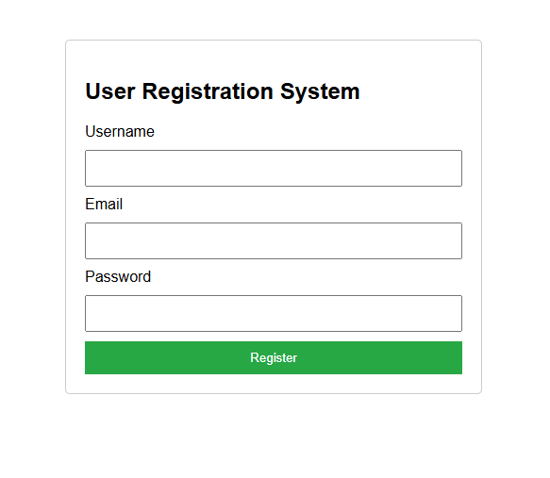

User List page: Here all the users will be listed, with the details that he entered during the registration.

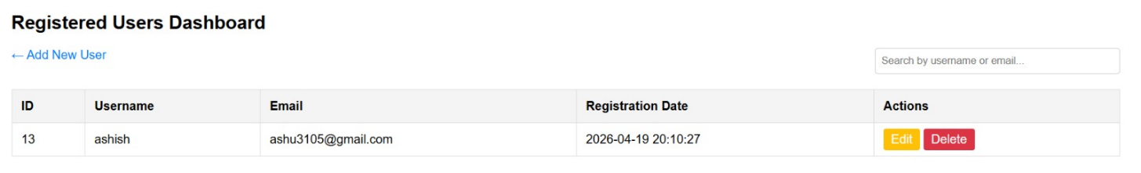
Editing page: Here we will be able to change his username and email.

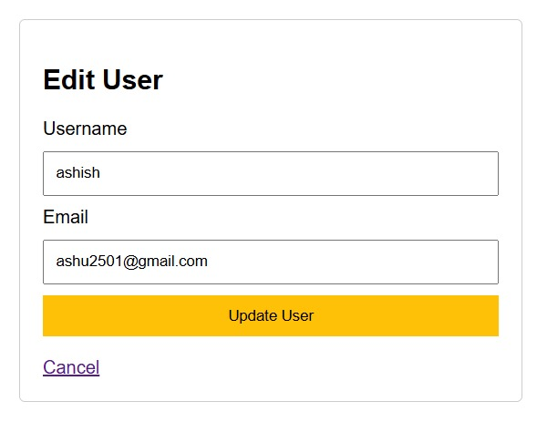

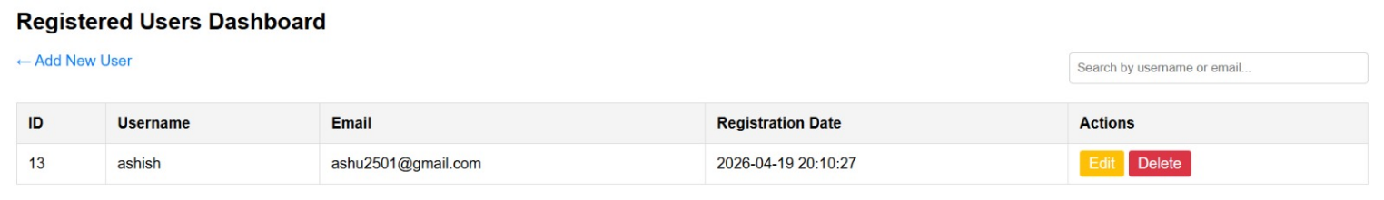

Delete page: We can delete the user, by clicking the “delete button”

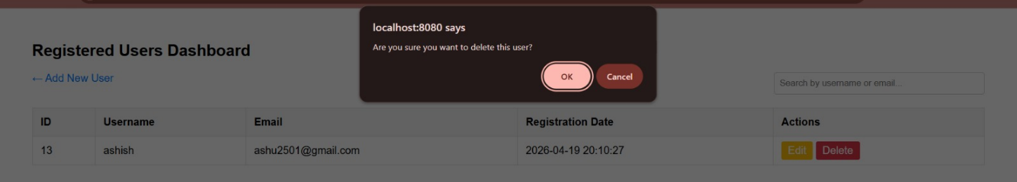
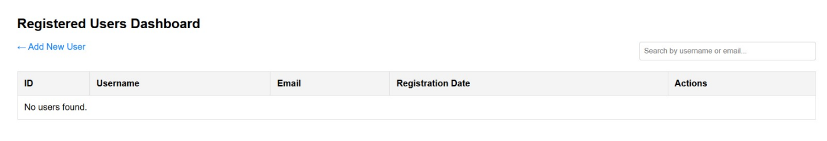

Conclusion
Thus, a dynamic database-driven web application was successfully developed using PHP and MySQL. CRUD operations were implemented with secure data handling, input validation, and session & cookie management. This experiment demonstrates real-world server-side web development concepts.
Question:
- What is the role of PHP in database connectivity?
Ans:
Definition: PHP acts as a server-side scripting language that connects web applications to databases (like MySQL).
Key Points:
- Establishes connection using functions like mysqli_connect() or PDO.
- Executes SQL queries (INSERT, UPDATE, SELECT, DELETE).
- Fetches and displays dynamic data on web pages.
- Provides error handling and secure communication with the database.

- Difference between session and cookie?
Ans:
Aspect | Session | Cookie
Definition | Server-side storage of user data | Client-side storage of user data in browser
Location | Stored on server | Stored on user’s computer
Security | More secure (not directly accessible by user) | Less secure (user can view/modify cookies)
Lifetime | Ends when browser is closed or session expires | Can persist for days/weeks until expiry date
Use Case | Login authentication, temporary data | Remembering preferences, auto-login

- How are passwords secured in PHP?
Ans:
Definition: PHP provides built-in functions to secure passwords before storing them in databases.
Key Points:
- Use password_hash() → generates a secure hash of the password.
- Use password_verify() → checks entered password against stored hash.
- Prevents storing plain-text passwords.
- Protects against attacks like brute force and SQL injection.

